When stakeholders have different opinions about the UI design of an e-commerce mobile app, a Figma prototype is created as a visual model of the app. This prototype shows how the app will look and function (like screens, navigation, buttons, etc.).
By presenting this interactive design to stakeholders, they can see, understand, and experience the app flow, making it easier to gather feedback, resolve conflicts, and get final approval before development begins.
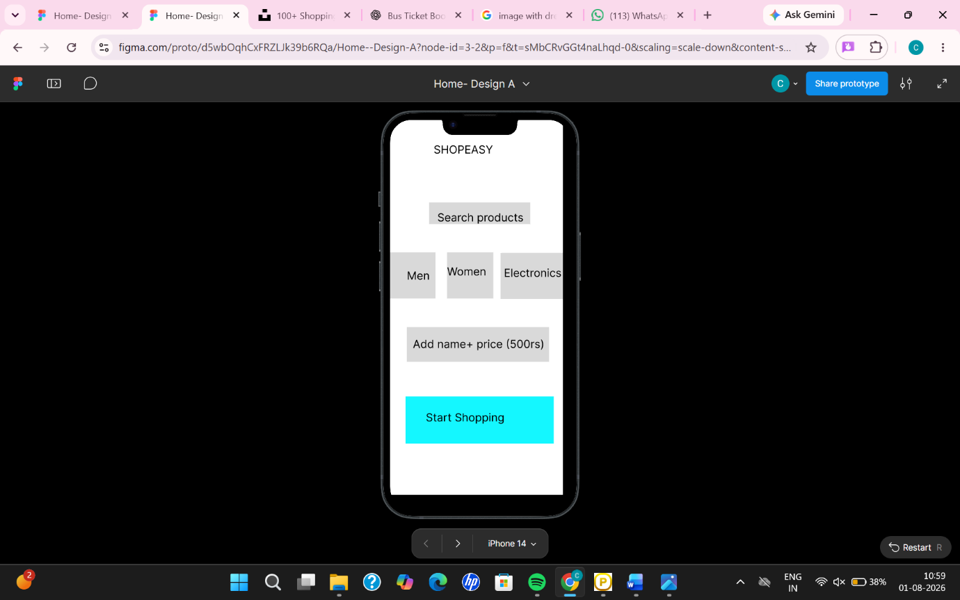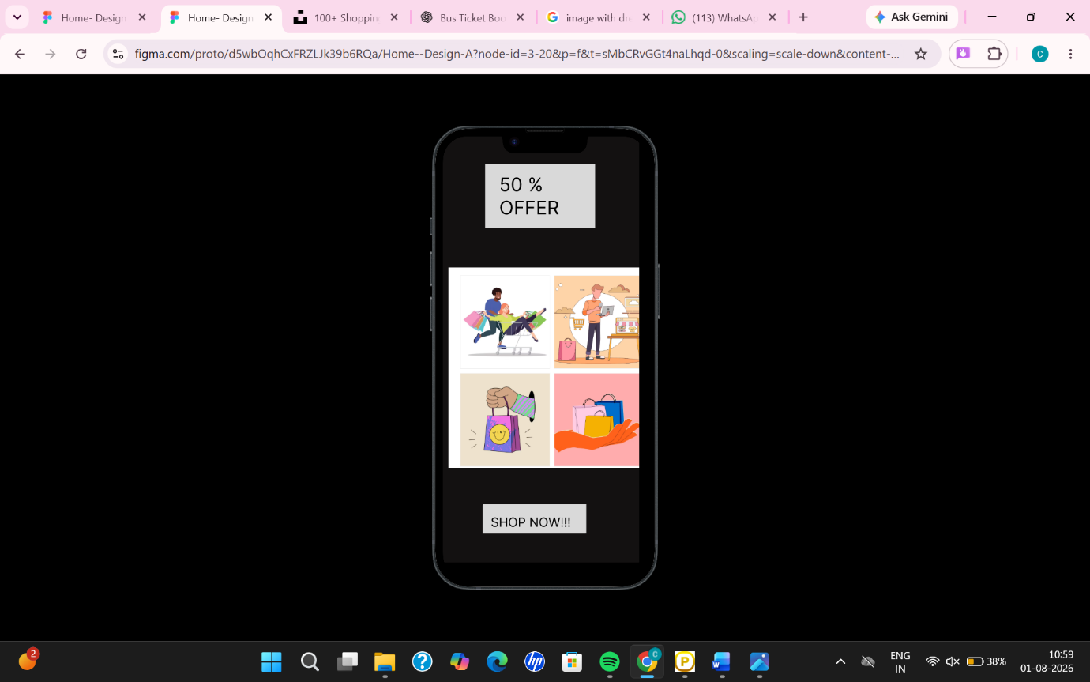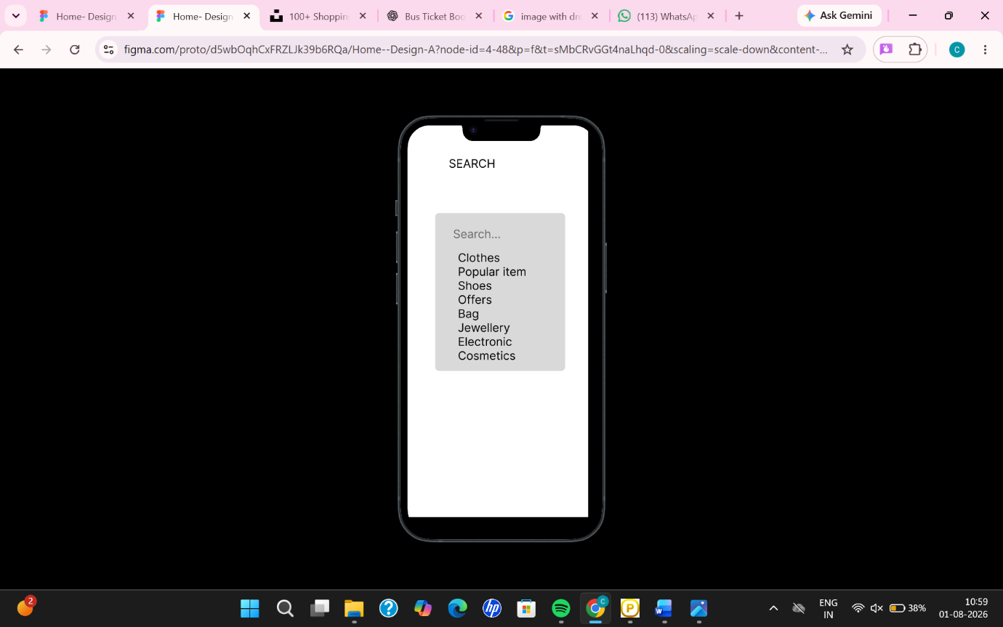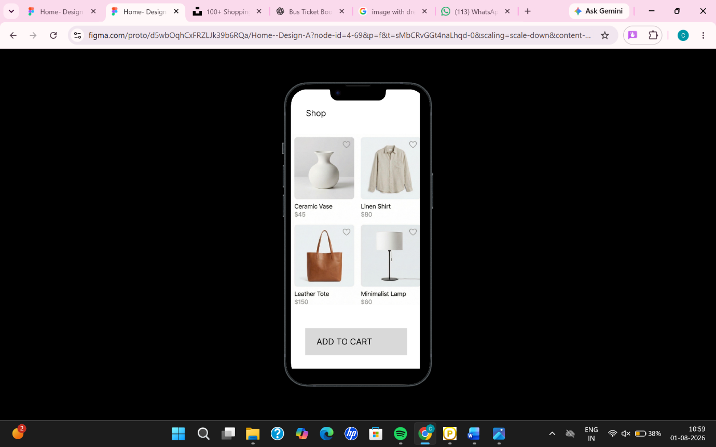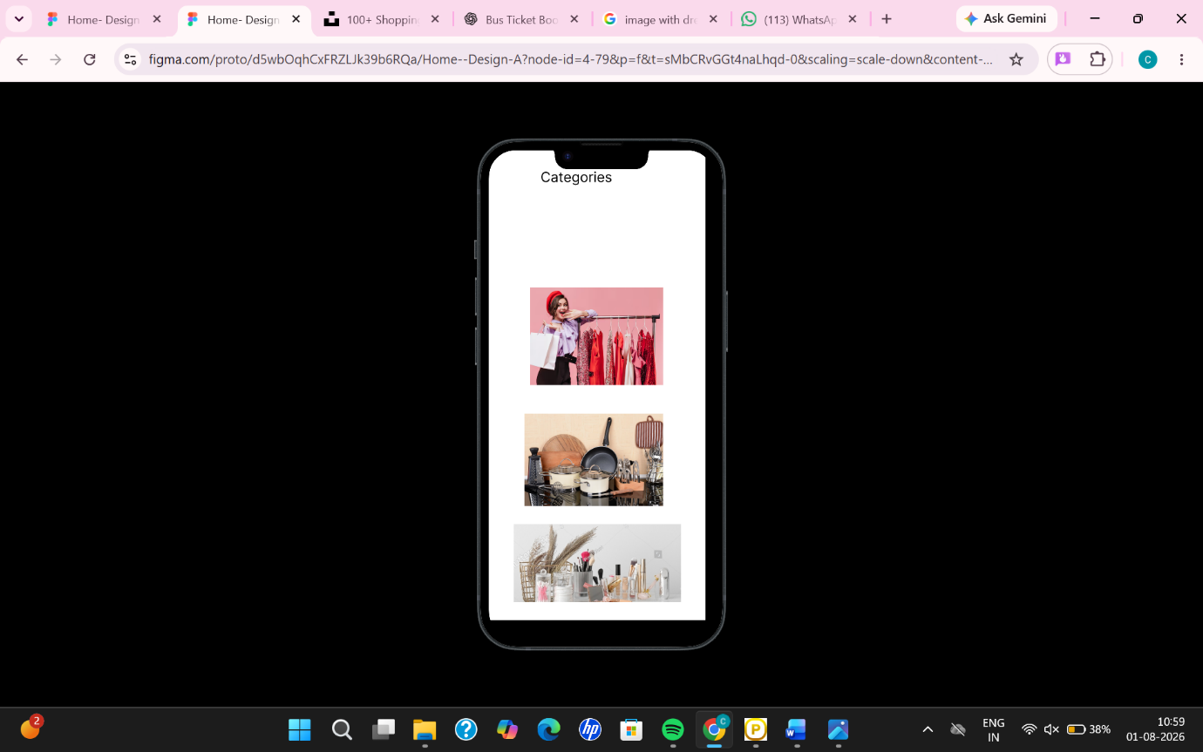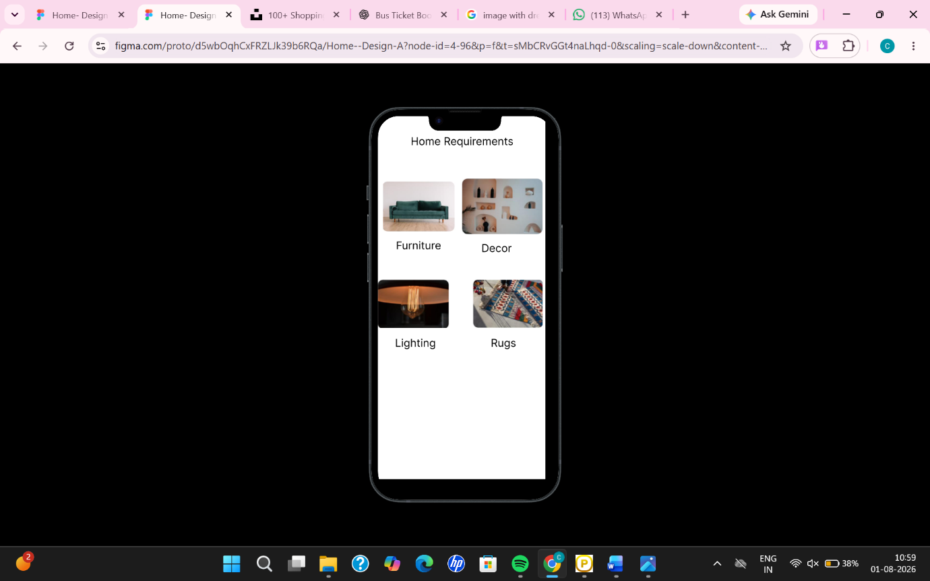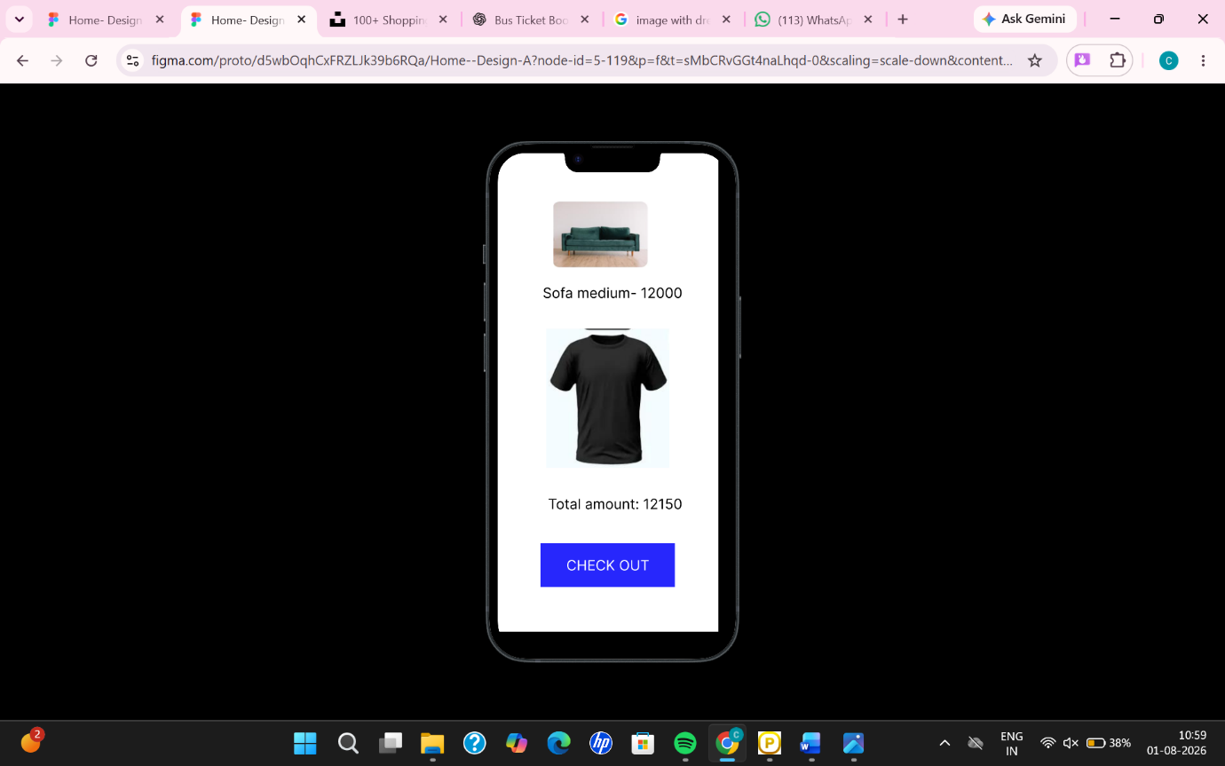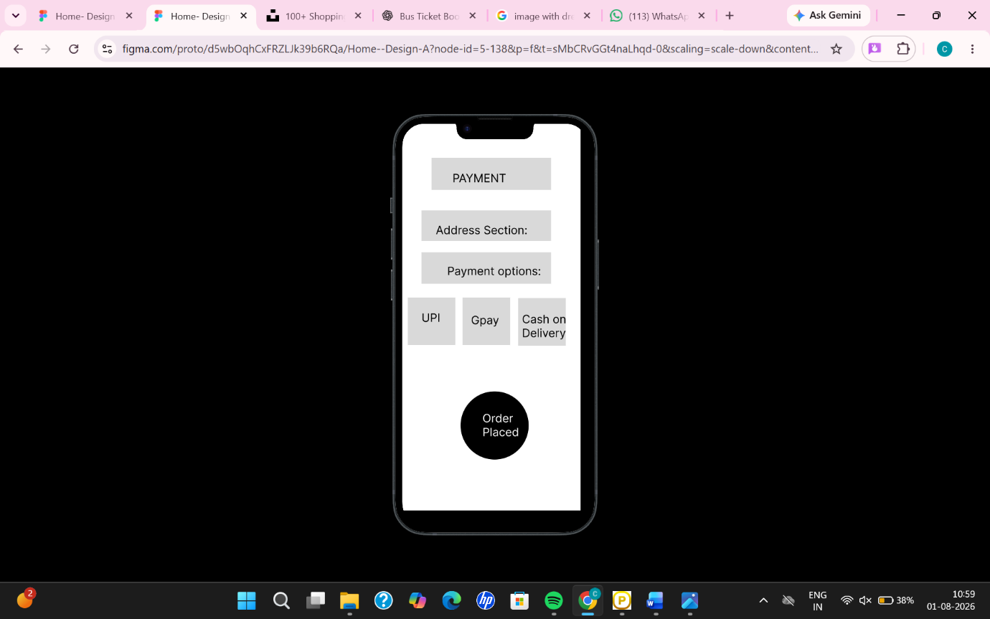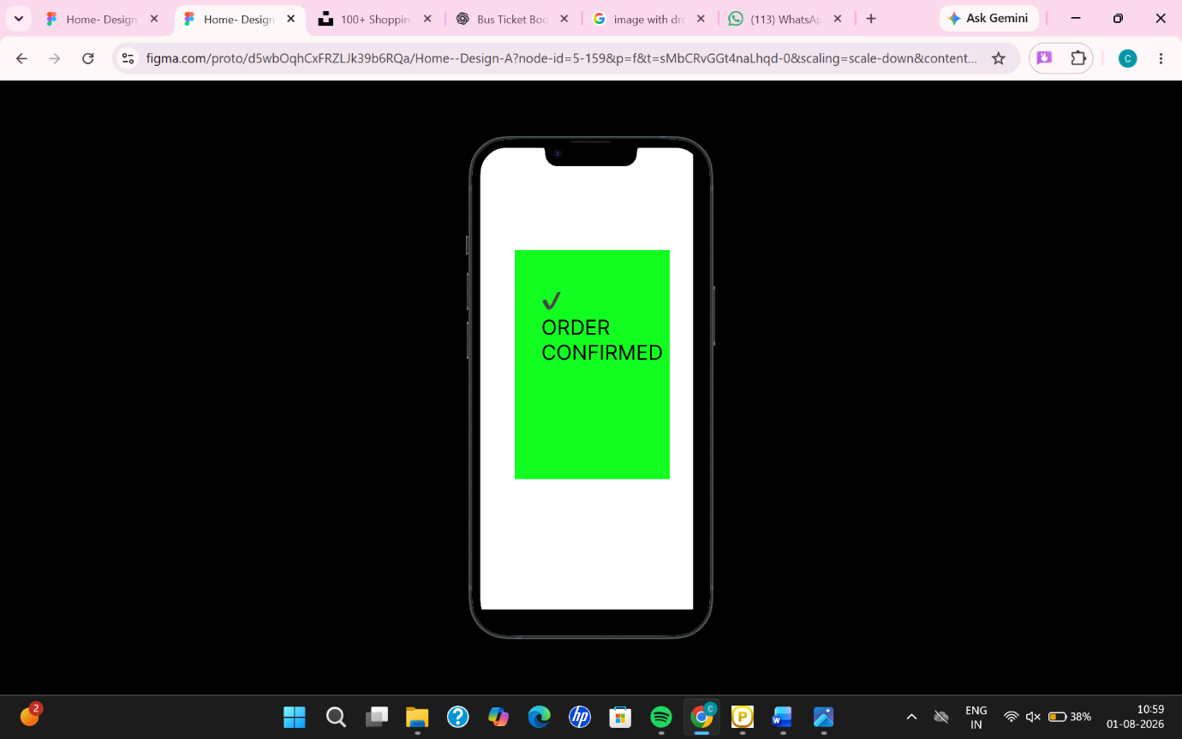

When stakeholders have different opinions about the UI design of an e-commerce mobile app, a Figma prototype is created as a visual model of the app. This prototype shows how the app will look and function (like screens, navigation, buttons, etc.).
By presenting this interactive design to stakeholders, they can see, understand, and experience the app flow, making it easier to gather feedback, resolve conflicts, and get final approval before development begins.

